

APPLIED DATABASE PROJECT 2

Advanced Features of an EMR Database System



## DECEMBER 11, 2019

ITIS 6120 - Applied Databases

**by**

Abhimanyu Singh Bisht

# Scope

Develop and maintain database system that serves as the backend of a simple EMR system that captures a small portion of relevant information of student clinic of UNCC university. Gather information which is digitally equivalent to paper records. Utilizing the gathered data for the treatment provided and maintaining medical history about the patient.

# Requirements Specification

The purpose of the Electronic Medical Records (EMRs) database is the systematized collection of patient health information and provider information in a digital format that can be created, gathered, managed, and consulted by authorized clinicians. By using this system, the outcome will be more predictable, the process will be more efficient, and the overall healthcare system will be more effective.

This project is in continuation of the previous work done. In the advance version of Electronic Medical Records (EMRs) database we have added additional features to facilitate more robust and efficient application development and to support security, privacy, audit trail and other regulatory requirements of an electronic medical records.

This document provides insight into additional tables, columns, stored procedures, triggers, indexes, views and other database functions that fulfill the new requirements.

For database security that seeks methods to protect stored data from intrusions, improper modifications and unauthorized disclosure of private information of patients. Therefore, the Database Design is composed of user authentication only for authorized users to access the database to make the security and privacy of database effective.

In order to provide documentary evidence of the sequence of activities that have affected at any time a specific operation, procedure, or event took place like updating the address of patient, for that we have added one more feature to enable audit trail.

# Create Additional Tables

CREATE TABLE `receptionist_information` (

`receptionist_id` int(11) PRIMARY KEY NOT NULL AUTO_INCREMENT,

`receptionist_name` varchar(50) NOT NULL,

`contact_number` varchar(50) DEFAULT NULL

);

CREATE TABLE `supplier` (

`supplier_id` varchar(50) PRIMARY KEY NOT NULL,

`supplier_name` varchar(50) NOT NULL,

`supplier_address` varchar(50) DEFAULT NULL,

`contact_number` varchar(50) DEFAULT NULL

);

CREATE TABLE `patient_information_audit` (

`patient_id` int(11) NOT NULL,

`patient_first_name` varchar(50) NOT NULL,

`patient_last_name` varchar(50) NOT NULL,

`patient_address` varchar(50) NOT NULL,

`patient_zip_code` varchar(20) NOT NULL,

`patient_phone` varchar(50) NOT NULL,

`action_type` varchar(50) NOT NULL,

`action_by` varchar(50) NOT NULL,

`action_date` datetime NOT NULL

);

CREATE TABLE `medicine_audit` (

`medicine_name` varchar(50) NOT NULL,

`medicine_price_USD` decimal(10,2) NOT NULL,

`supplier_id` varchar(50) NOT NULL,

`action_type` varchar(50) NOT NULL,

`action_by` varchar(50) NOT NULL,

`action_date` datetime NOT NULL

);

# Inserting Data to the Additional Tables

INSERT INTO receptionist_information VALUES (901, 'Alyssa', 9876543210 ),

(902, 'Kevin', 6543217890),

(903, 'Rishi', 3216598740 );

INSERT INTO supplier VALUES

('X', 'Get Well', 'Charlotte', 9876543210 ), ('Y', 'Wallgreens', 'Concord', 6543217890);

# ER DIAGRAM

An Entity Relationship Diagram (ERD) is a snapshot of data structures. An Entity Relationship Diagram shows entities (tables) in a database and relationships between tables within that database. Below is a snapshot of the database emr_db5

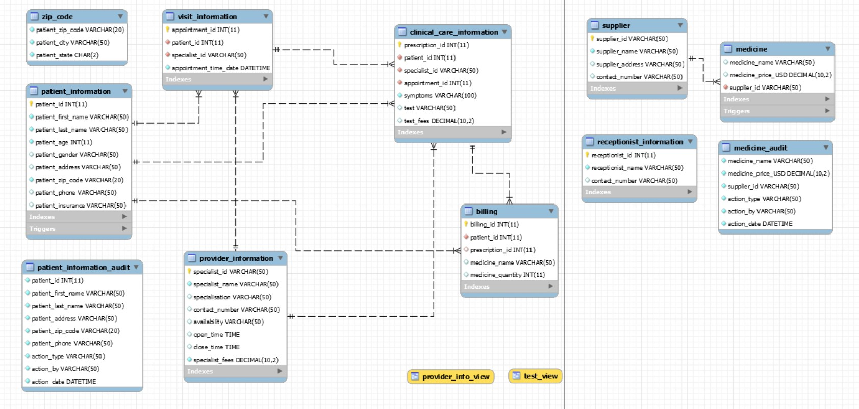

# UML DIAGRAM

A UML diagram is a diagram based on the Unified Modeling Language with the purpose of visually representing a system along with its main actors, roles, actions, artifacts or classes, in order to better understand, alter, maintain, or document information about the system.

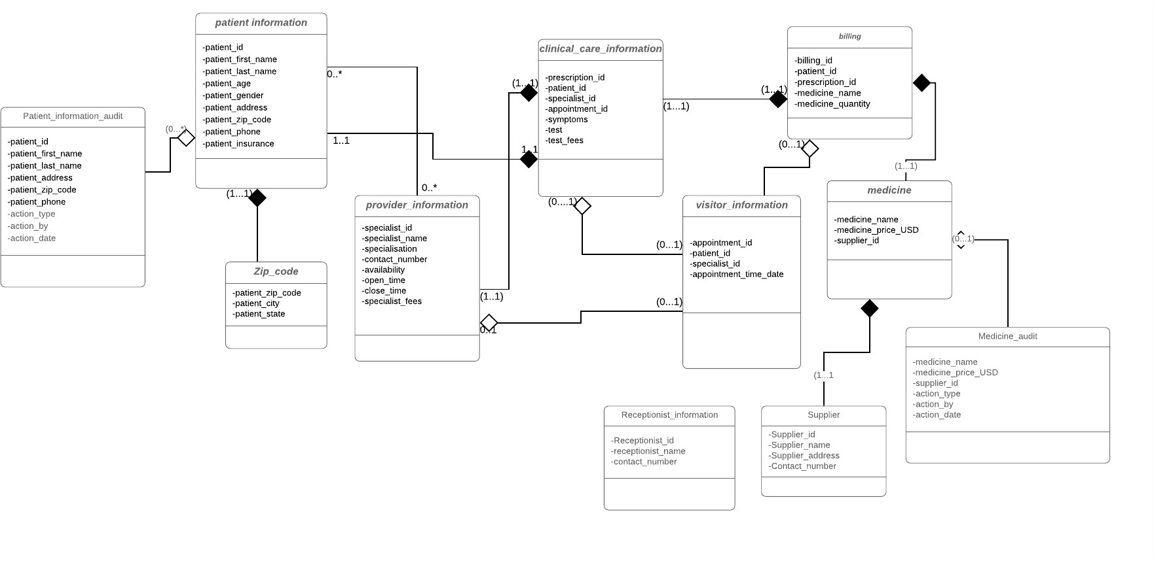

# Stored Procedure

A stored procedure is a database object that contains a block of procedural SQL code. We can use stored procedures to modify the data that's stored within a database. Using stored procedure, we can execute an insert, update and delete operations. Stored procedures are executed using CALL function.

## Select statement using procedure

Drop procedure if exists API_patient_information; DELIMITER //

CREATE PROCEDURE API_patient_information (

patient_id_para int

)

BEGIN

SELECT patient_id, concat(patient_first_name, ' ' , patient_last_name) as FullName,

patient_phone, patient_address FROM patient_information

WHERE patient_id = patient_id_para; END //

## Scenario

*Select Patient Id, Patient Full Name, Patient Phone and Patient Address of the patient with id 2 using Stored Procedure and Call function.*

call API_patient_information(2);

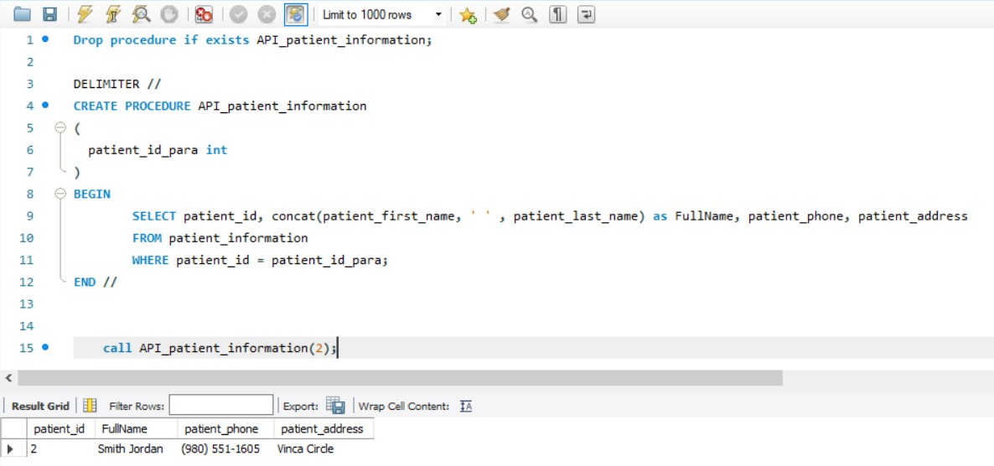

## Insert statement using procedure

DROP PROCEDURE IF EXISTS API_insert_billing; DELIMITER //

CREATE PROCEDURE API_insert_billing (

billing_id_para int, patient_id_para int, prescription_id_para int,

medicine_name_para varchar(100), medicine_quantity_para int

)

BEGIN

DECLARE sql_error TINYINT DEFAULT FALSE;

DECLARE CONTINUE HANDLER FOR SQLEXCEPTION

SET sql_error = TRUE;

START TRANSACTION;

insert into billing(billing_id,patient_id,prescription_id,medicine_name,medicine_quantity) values(billing_id_para,patient_id_para,prescription_id_para,medicine_name_para,medicine_quantity_para);

IF sql_error = FALSE THEN COMMIT;

ELSE

ROLLBACK;

END IF;

END//

DELIMITER ;

## Scenario

*Insert a new billing for patient id 9 with prescription id 1027 and 2 quantities of Nyquil medicine.*

call API_insert_billing(531,9,1027,'Nyquil',2); SELECT * FROM billing WHERE billing_id = 531;

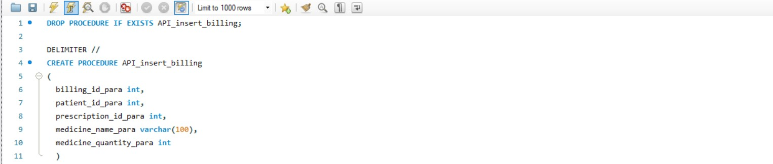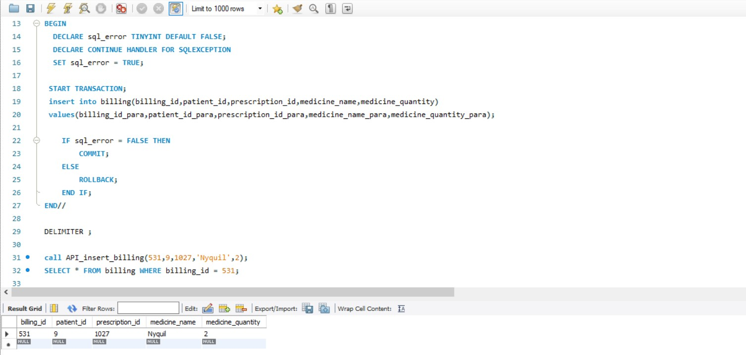

## Update statement using procedure

DROP PROCEDURE IF EXISTS API_update_provider_information; DELIMITER //

CREATE PROCEDURE API_update_provider_information (

Specialist_id_parameter varchar(50), Contact_number_parameter VARCHAR(100)

)

BEGIN

DECLARE sql_error TINYINT DEFAULT FALSE;

DECLARE CONTINUE HANDLER FOR SQLEXCEPTION

SET sql_error = TRUE;

START TRANSACTION;

Update provider_information

set contact_number = contact_number_parameter where specialist_id = specialist_id_parameter;

IF sql_error = FALSE THEN

COMMIT;

ELSE

ROLLBACK;

END IF;

END//

DELIMITER ;

## Scenario

*Update the phone number of the specialist with id A103 to (888) 547-7755 in the provider_information table.*

call API_update_provider_information ('A103','(888) 547-7755'); select * from provider_information where specialist_id='A103';

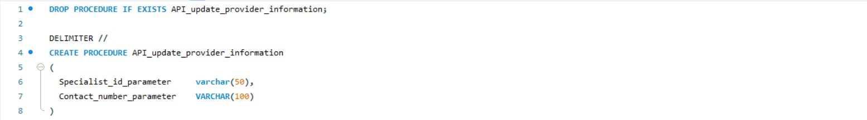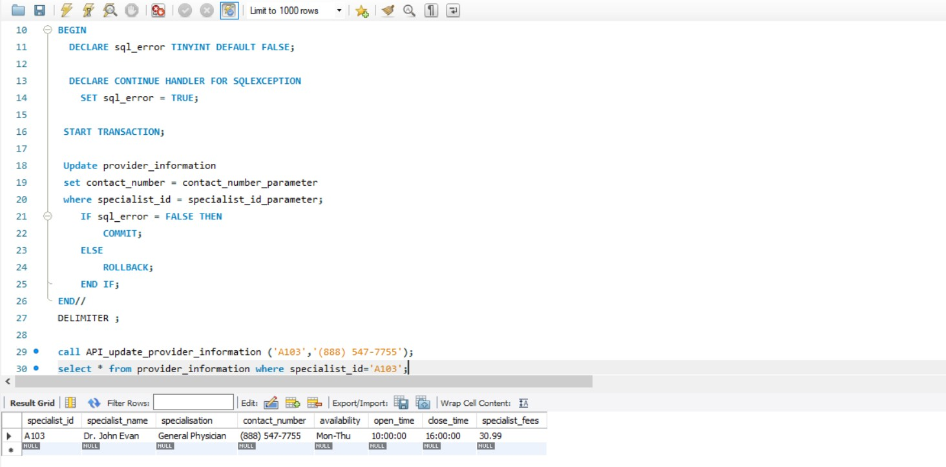

## Delete statement using procedure

DROP PROCEDURE IF EXISTS API_delete_medicine; DELIMITER //

CREATE PROCEDURE API_delete_medicine (

medicine_name_para varchar(100)

)

BEGIN

DECLARE sql_error TINYINT DEFAULT FALSE;

DECLARE CONTINUE HANDLER FOR SQLEXCEPTION

SET sql_error = TRUE; START TRANSACTION;

delete from medicine where medicine_name = medicine_name_para; IF sql_error = FALSE THEN

COMMIT;

ELSE

ROLLBACK;

END IF;

END//

DELIMITER ;

## Scenario

*Delete Paracetamol 500 from the medicine table.*

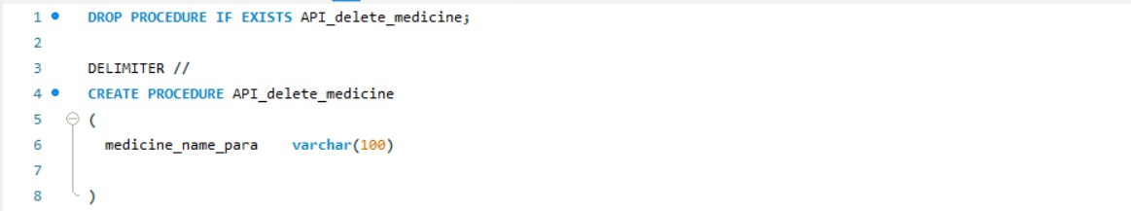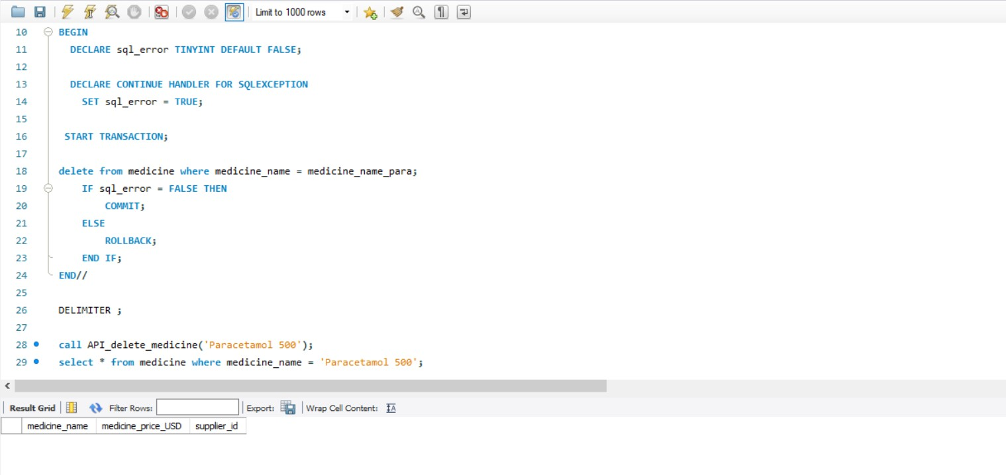

# User Authentication

Following are the five users of emr_db5 database:

* 1. root (Administrator)
  2. specialist_user
  3. receptionist_user
  4. supplier_user
  5. patient_user

Except the root user, the other four are newly created with the given password. User Logins are also created after creating the users.

CREATE USER 'specialist_user'@'localhost' IDENTIFIED BY 'xyz123'; CREATE USER 'receptionist_user'@'localhost' IDENTIFIED BY '12345'; CREATE USER 'supplier_user'@'localhost' IDENTIFIED BY 'abc123'; CREATE USER 'patient_user'@'localhost' IDENTIFIED BY 'home123';

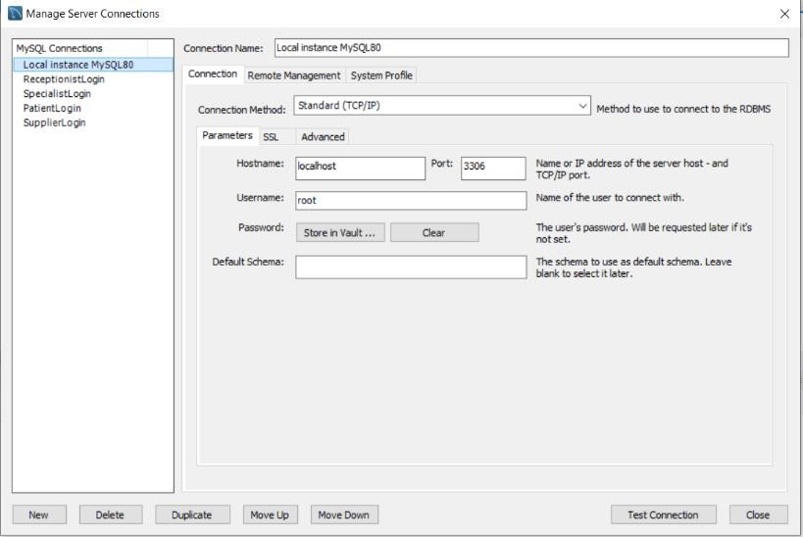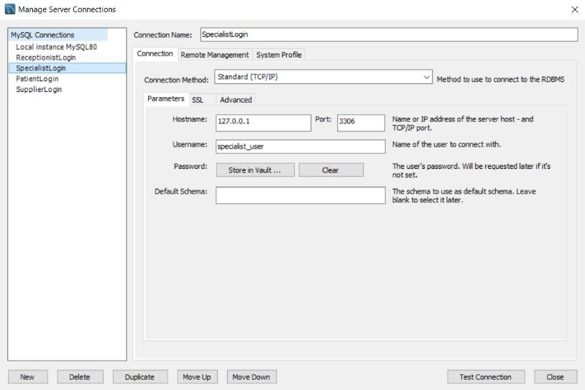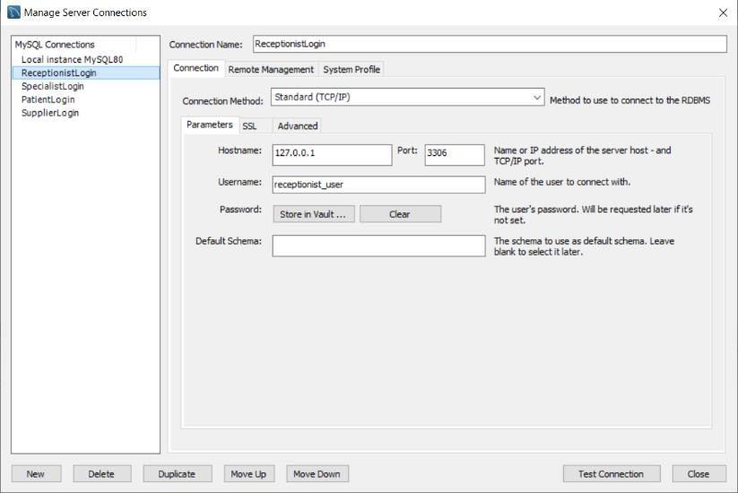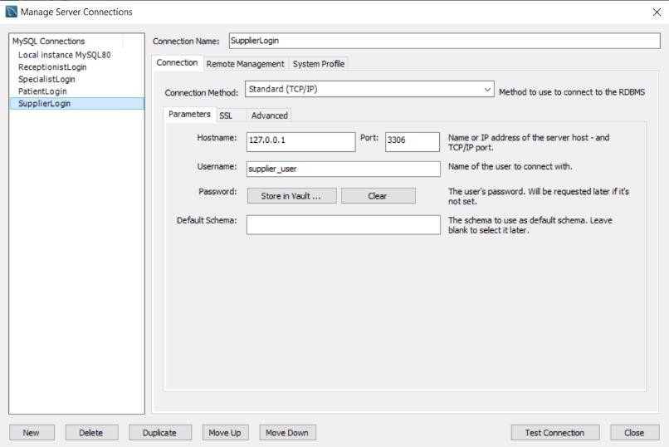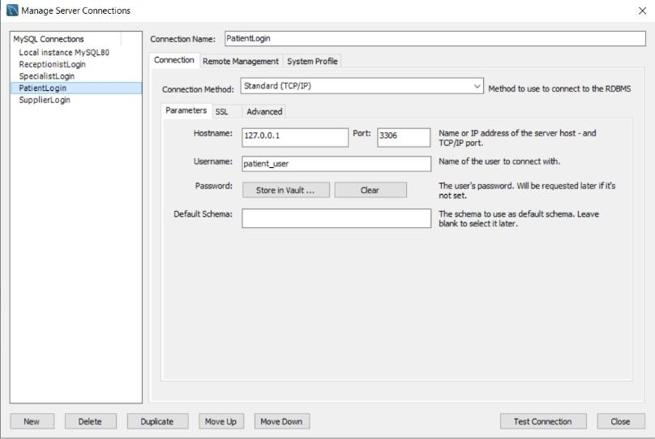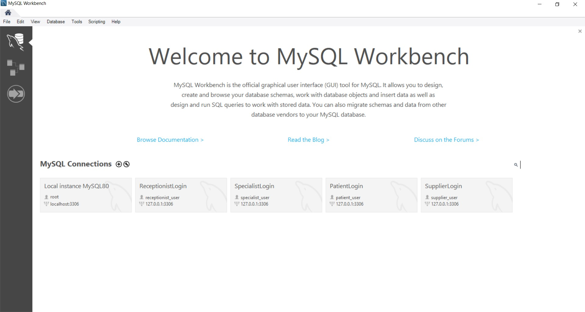

# Role-Based Access Control

1. ‘root’ user is the admin and he/she can access all the tables of the database system. Also, the root user can do all the operations and can make changes in any of the table.

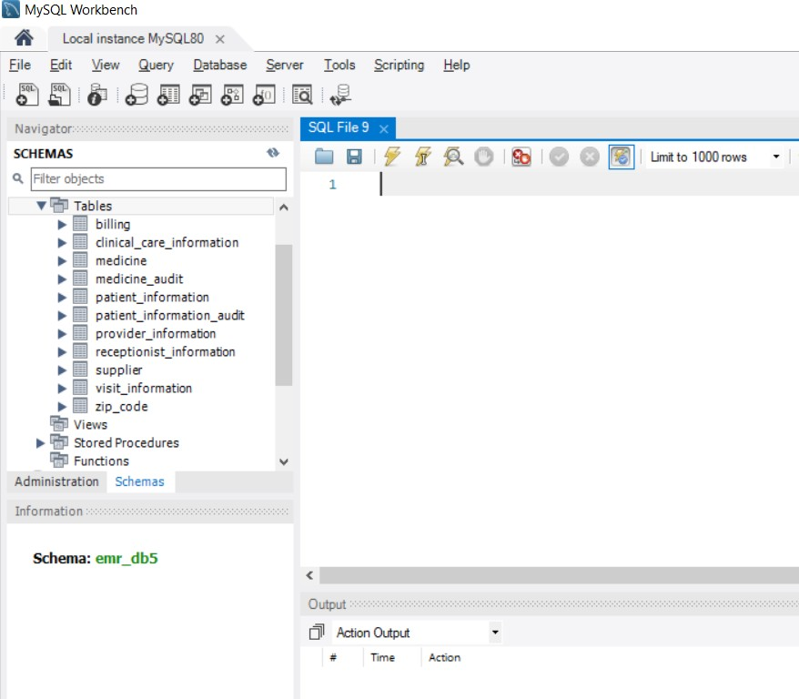

1. ‘specialist_user’ is given read only access to provider_information table to view all the doctors’ information, whereas it has been given read and write access to clinical_care_information table to view, insert, update and delete patient’s clinical details. Hence, specialist_user cannot access any other table of the database.

GRANT SELECT ON emr_db5.provider_information TO 'specialist_user'@'localhost';

GRANT SELECT, INSERT, UPDATE, DELETE ON emr_db5.clinical_care_information TO 'specialist_user'@'localhost';

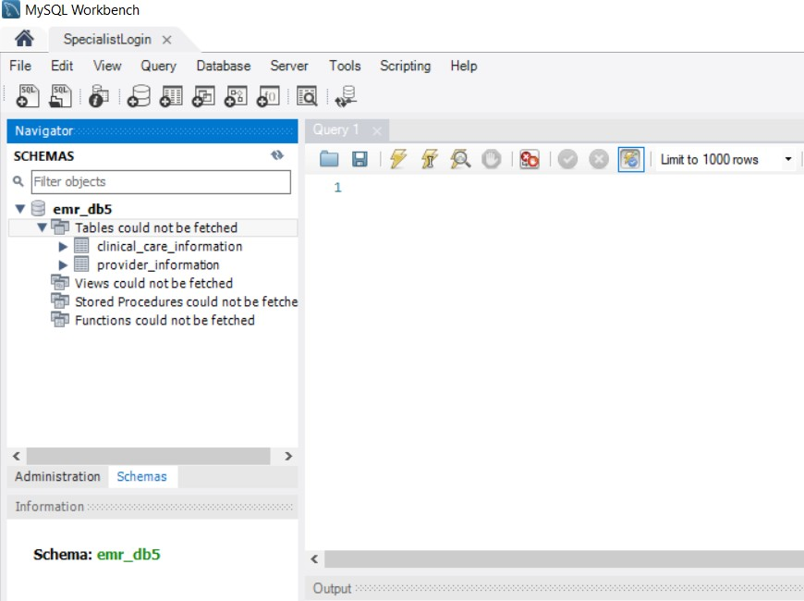

## Scenario I

*Update the specialist_fees to 25.00 of the specialist with id A101 in the provider_information table.*

update provider_information set specialist_fees=25.00 where specialist_id='A101';

select * from provider_information where specialist_id='A101';

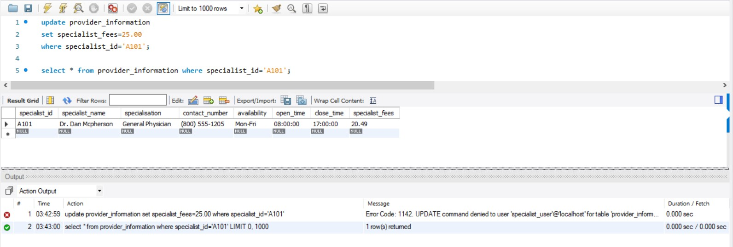

Here, the specialist_user cannot update the provider_information table, but he/she can view the table data.

## Scenario II

*Update symptoms to Stomach Pain of the patient with prescription id 1001 in the clinical_care_information table.*

update clinical_care_information set symptoms='Stomach Pain' where prescription_id=1001;

select * from clinical_care_information where patient_id=1;

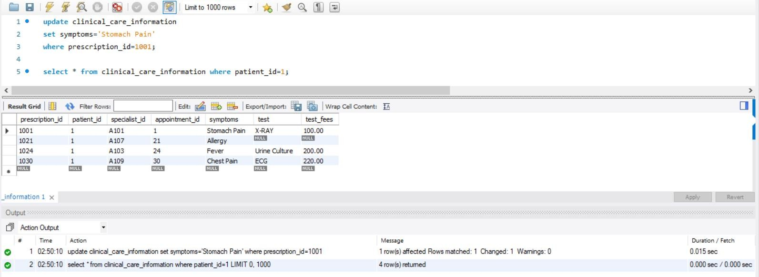

Here, the specialist_user can update and view the clinical_care_information table.

1. ‘receptionist_user’ is given read only access to provider_information table to view all the doctors’ information, whereas it has been given read and write access to billing, visit_information and patient_information table to view, insert, update and delete patient’s profile, visit and billing details. Hence, receptionist_user cannot access any other table of the database.

GRANT SELECT ON emr_db5.provider_information TO 'receptionist_user'@'localhost';

GRANT SELECT, INSERT, UPDATE, DELETE ON emr_db5.billing TO 'receptionist_user'@'localhost';

GRANT SELECT, INSERT, UPDATE, DELETE ON emr_db5.visit_information TO 'receptionist_user'@'localhost';

GRANT SELECT, INSERT, UPDATE ON emr_db5.patient_information TO 'receptionist_user'@'localhost';

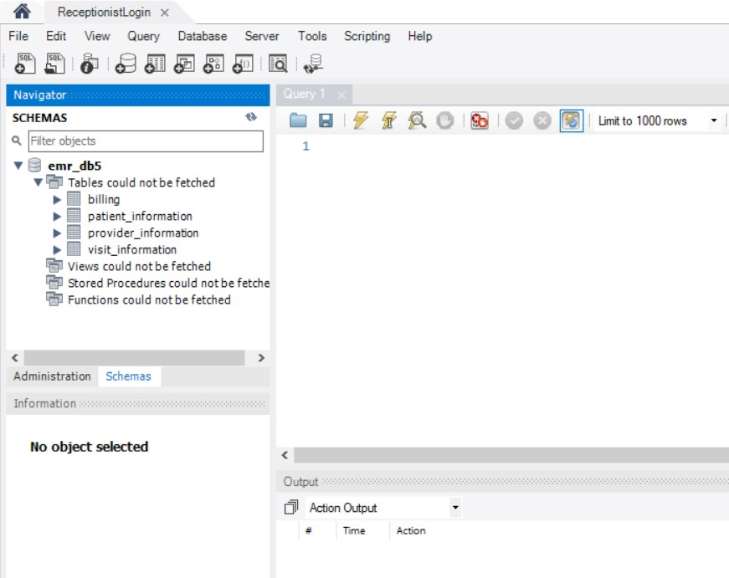

## Scenario I

*Update the specialist_fees to 25.00 of the specialist with id A101 in the provider_information table.*

update provider_information set specialist_fees=25.00 where specialist_id='A101';

select * from provider_information where specialist_id=’A101’;

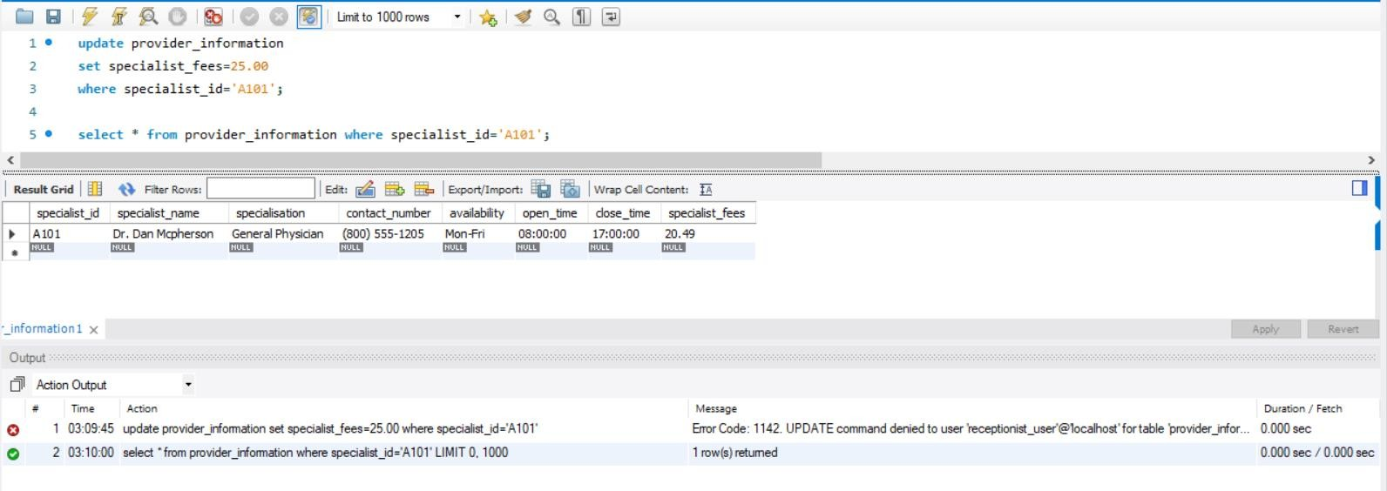

Here, the receptionist_user cannot update the provider_information table, but he/she can view the table data.

## Scenario II

*Insert a new entry in the visit_information table with appointment id 31 for patient id 20 and specialist id A109 on 2019-11-05 at 12:30:00.*

insert into visit_information values (31,20,'A109', '2019-11-05 12:30:00'); select * from visit_information where appointment_id=31;

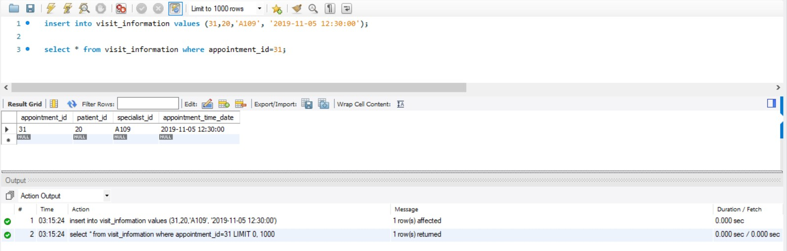

Here, the receptionist_user can insert and view the visit_information table.

1. ‘supplier_user’ has been given read and write access to medicine table to view, insert, update and delete medicine details. Hence, supplier_user cannot access any other table of the database.

GRANT SELECT, INSERT, UPDATE, DELETE ON emr_db5.medicine TO 'supplier_user'@'localhost';

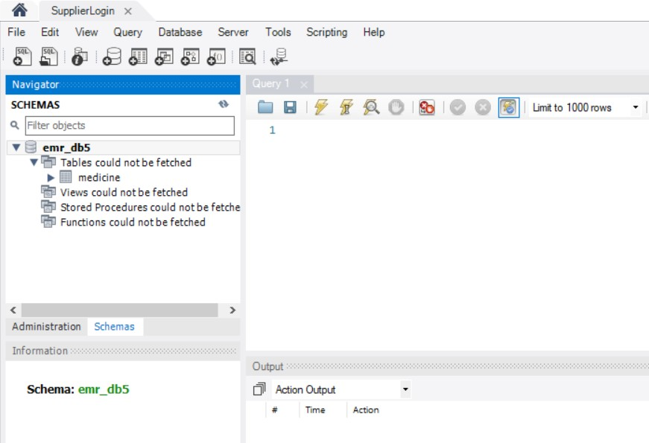

## Scenario

*Update the medicine price to 3.5 USD of Crocin in the medicine table.*

update medicine

set medicine_price_USD=3.50 where medicine_name='Crocin';

select * from medicine where medicine_name='Crocin';

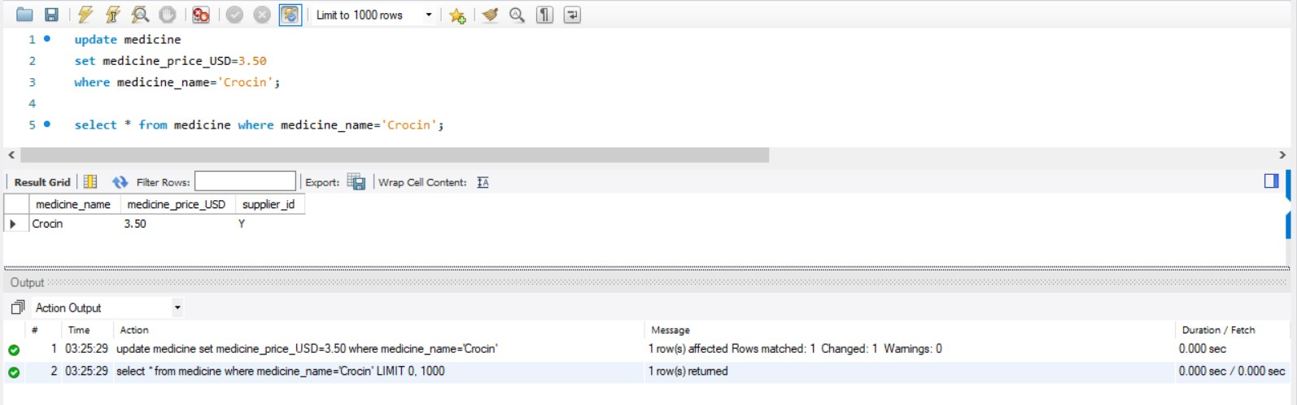

Here, the suplier_user can update and view the medicine table.

1. ‘patient_user’ is given read only access to patient_information table to view patient’s information. Hence, patient_user cannot access any other table of the database.

GRANT SELECT ON emr_db5.patient_information TO 'patient_user'@'localhost';

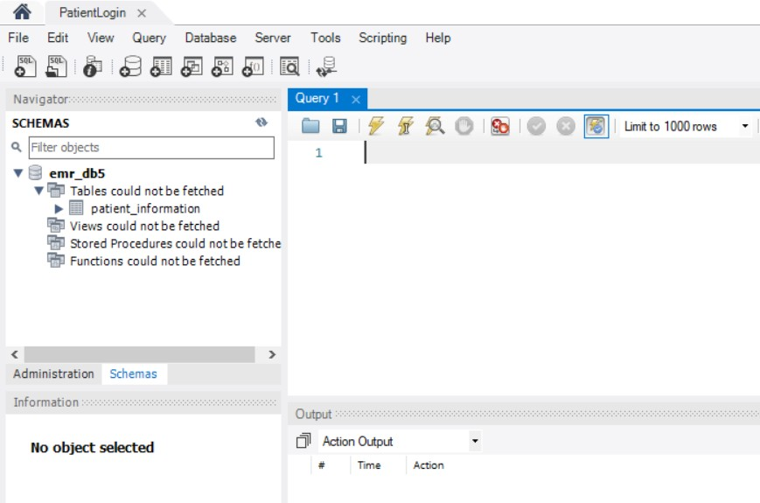

## Scenario

*Update the patient’s age to 28 of the patient with id 3 in the patient_information table.*

update patient_information set patient_age=28

where patient_id=3;

select * from patient_information where patient_id=3;

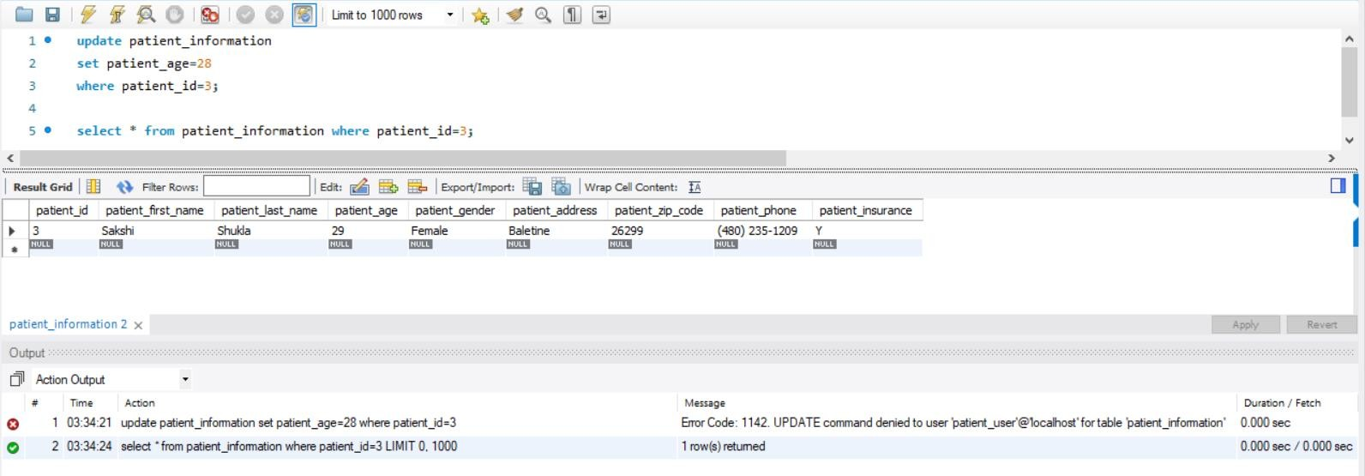

Here, the patient_user cannot update the patient_information table, but he/she can view the table data.

# Audit Trail: Triggers

A trigger is a block of code that is executed or fired automatically when a particular type of SQL statement is executed. Triggers can be fired before or after when an insert, update and delete statement is executed on a table.

## Audit trail while data is Updated

DROP TRIGGER IF EXISTS patient_information_after_update; DELIMITER //

CREATE TRIGGER patient_information_after_update AFTER UPDATE ON patient_information

FOR EACH ROW BEGIN

INSERT INTO patient_information_audit VALUES

(OLD.patient_id, OLD.patient_first_name, OLD.patient_last_name, OLD.patient_address, OLD.patient_zip_code, OLD.patient_phone, 'UPDATED', session_user(), NOW());

END// DELIMITER ;

## Scenario

*Update the patient phone number to (256) 654-6542 of the patient with id 11 in the patient_information table and maintain the old data in the audit table.*

UPDATE patient_information

SET patient_phone = '(256) 654-6542' WHERE patient_id = 11;

select * from patient_information where patient_id=11;

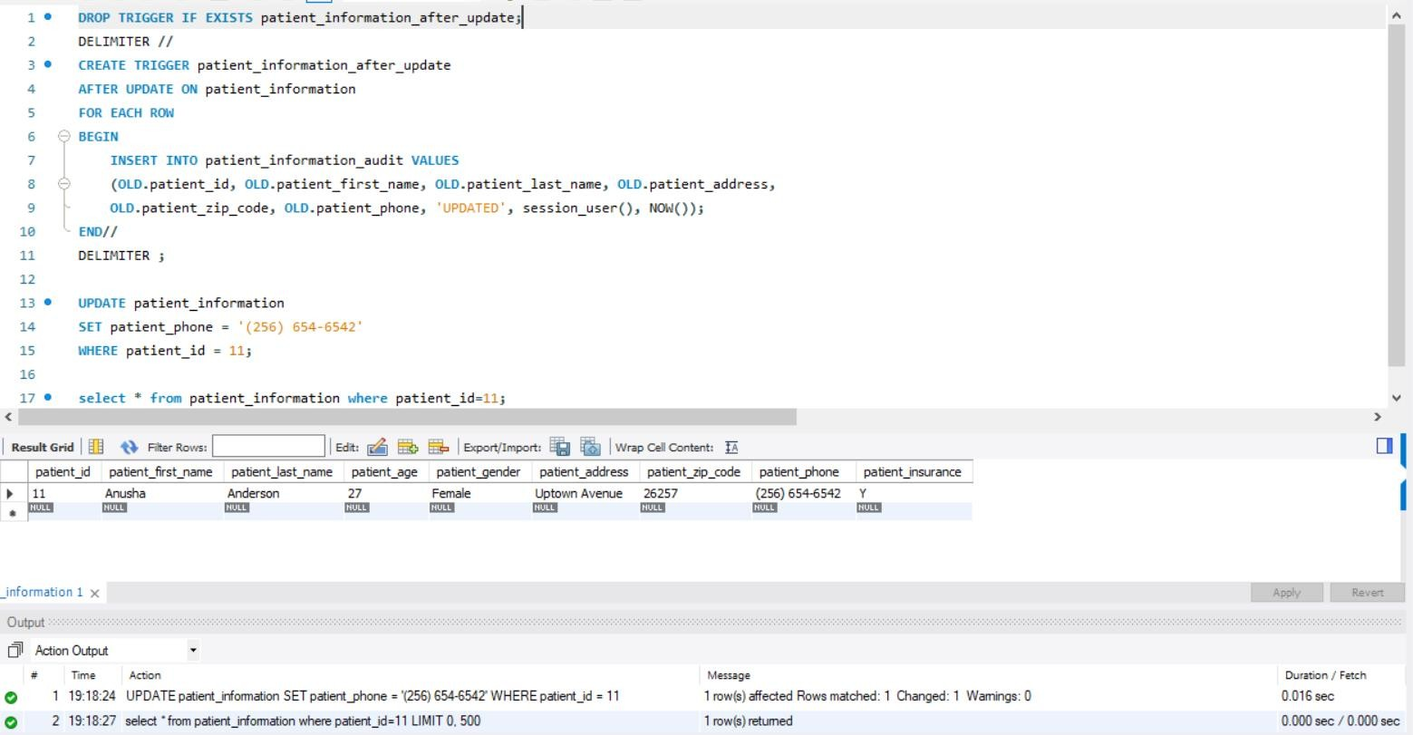

select * from patient_information_audit;

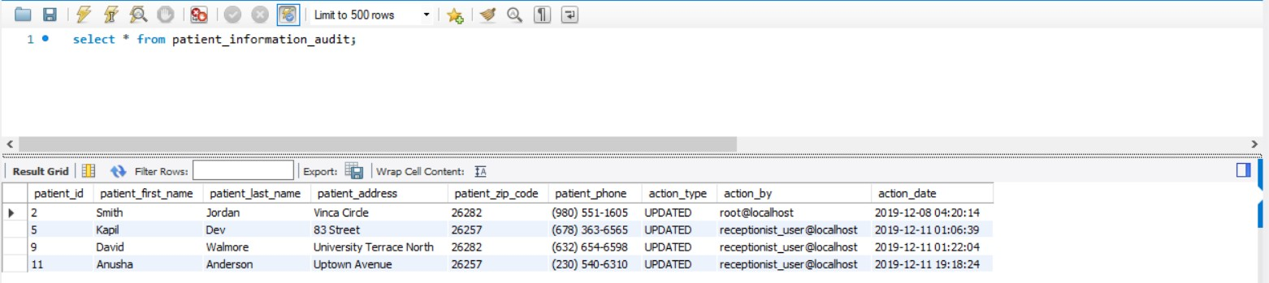

New data is updated in the original table and old data history is maintained in the patient_information_audit table with the action type, time and the user details who has done the action.

## Audit trail while data is Deleted

DROP TRIGGER IF EXISTS medicine_after_delete; DELIMITER //

CREATE TRIGGER medicine_after_delete

AFTER DELETE ON medicine FOR EACH ROW

BEGIN

INSERT INTO medicine_audit VALUES

(OLD.medicine_name, OLD.medicine_price_USD, OLD.supplier_id, 'DELETED', session_user(), NOW()); END; //

DELIMITER ;

## Scenario

*Delete the medicine Crocin from the medicine table and maintain the old data in the audit table.*

delete from medicine

where medicine_name='Crocin';

select * from medicine where medicine_name='Crocin';

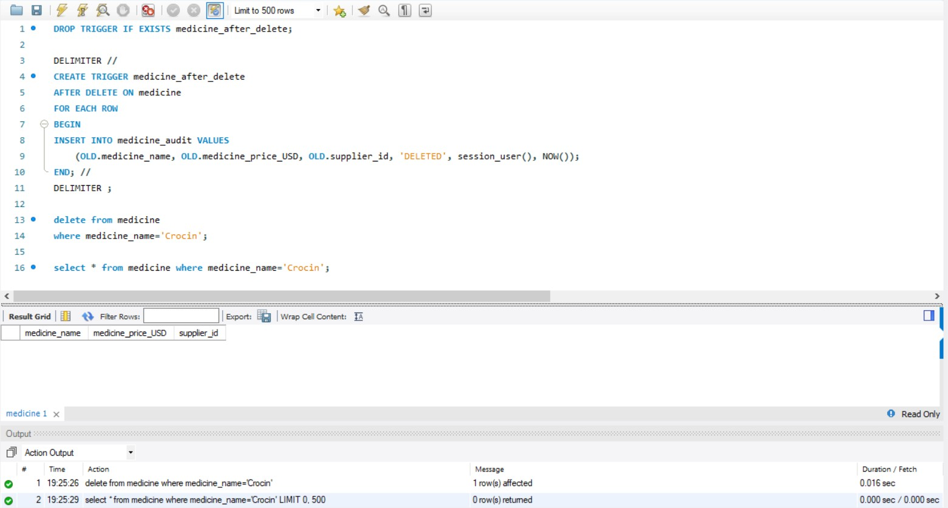

select * from medicine_audit;

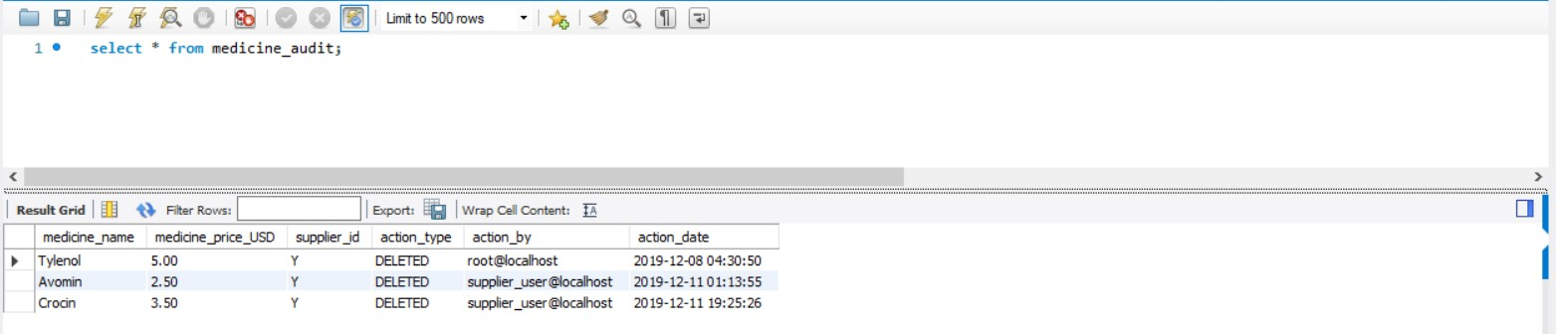

Data is deleted from the original table and old data history is maintained in the medicine_audit table with the action type, time and the user details who has done the action.

# Index

## An index speeds up joins and searches by providing a way for a database management system to go directly to a row rather than having to search through all the rows until it finds the one the user wants. By default, MySQL creates indexes for primary keys, foreign keys, and unique keys of a table. Here, we have created indexes for columns that are frequently used. However, we avoid creating Indexes on columns which are frequently updated as it will slow down Insert, Update and Delete operations.

* Scenario

*Check the execution time with and without using the index when a receptionist tries to view specialist name, specialisation, availability, open and close time, specialist fees from the provider_information table.*

### Without index:

select specialist_name, specialisation, availability, open_time, close_time, specialist_fees from provider_information;

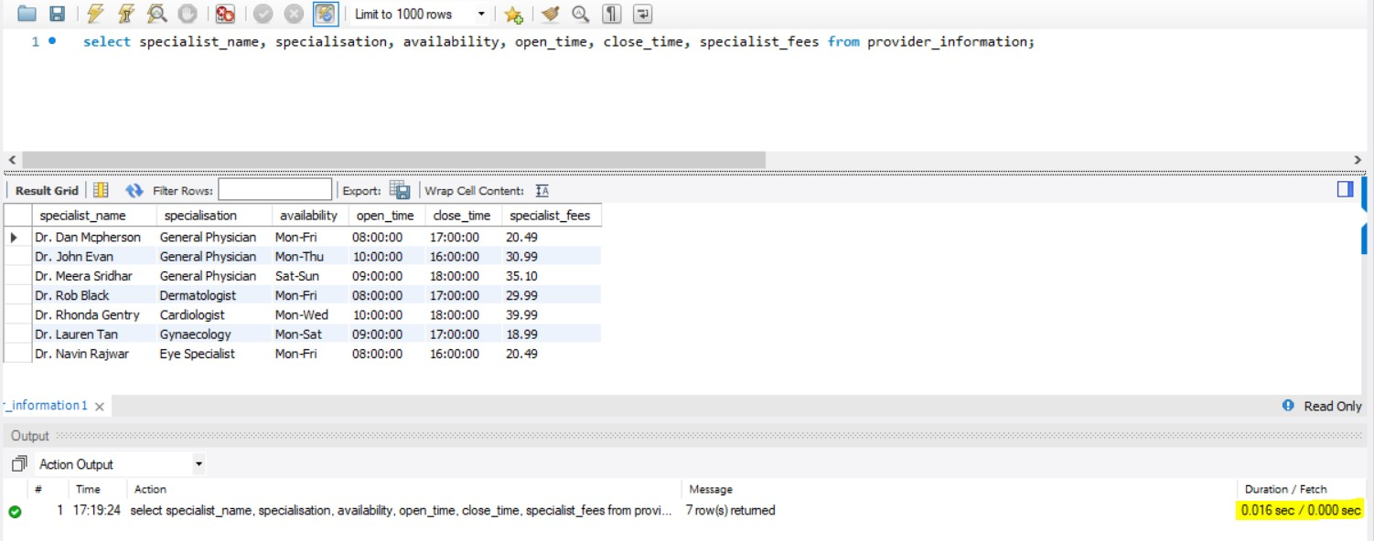

### With Index:

create index provider_information_index

on provider_information (specialist_name, specialisation, availability, open_time, close_time, specialist_fees);

select specialist_name, specialisation, availability, open_time, close_time, specialist_fees from provider_information;

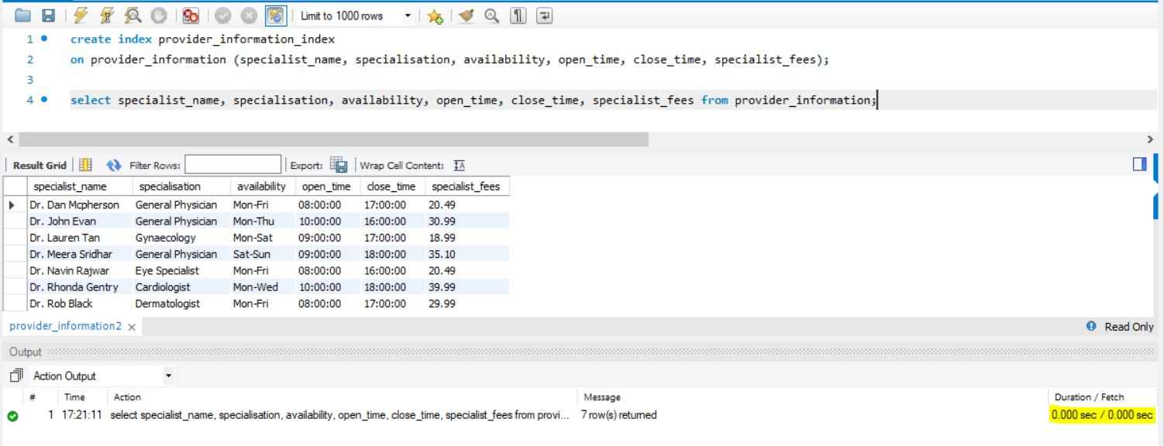

The execution time is less when we use index on some of the columns of the provider_information table.

# Views

A view is a select statement that is stored in the database as a database object. A view can be thought of a virtual table that consist of rows and columns specified in CREATE VIEW statement. To use a view, we can refer to it from another SQL statement :

## Scenario I

*Create a view on provider_information table and show a select statement that uses the view.*

create view provider_info_view as

select specialist_name, availability, open_time, close_time, specialist_fees from provider_information;

select * from provider_info_view;

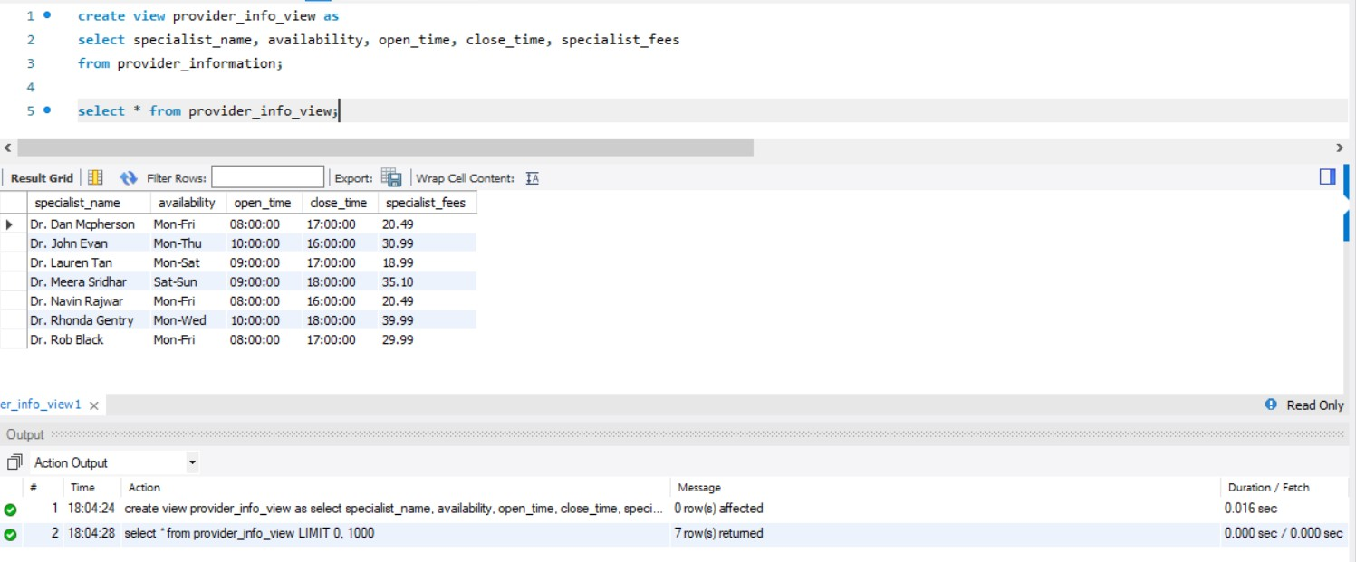

## Scenario II

*Create a view on clinical_care_information table and show an update statement that uses the view.*

create view test_view as

select symptoms, test, test_fees from clinical_care_information;

update test_view set test_fees= 150

where test= 'X-Ray';

select * from clinical_care_information where test='X-Ray';

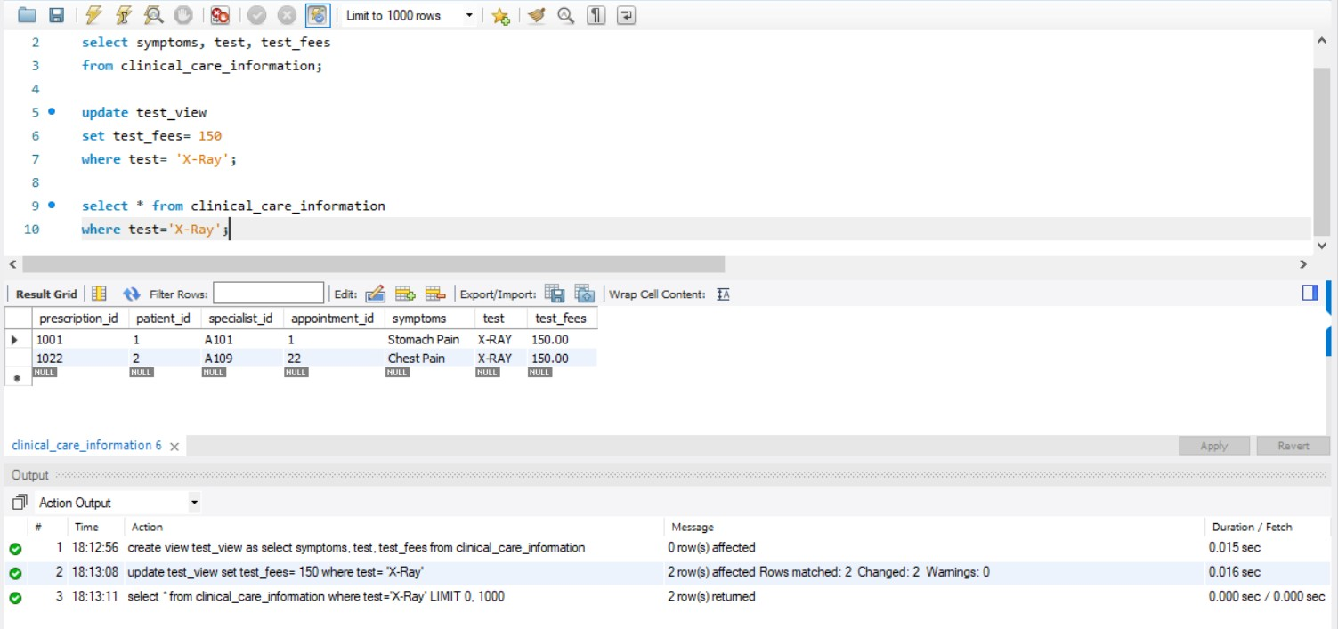

# Future Enhancements

In the coming future the scope of the project can be expanded, and this project can be updated. Using the same scenarios and the same requirement arises, the project is flexible enough in terms of expansion. More tables can be added to capture other relevant data like the Insurance availed by students, test rooms availability, diagnosis exam etc. for the future enhancement. Also, index and view can used in so many places as per requirements. Audit tables can be made for different original tables. Stored procedure and triggers can be used in different ways in different areas.

# SQL Scripts

      

Create_EMR_DB5 V2.sql

InsertValues_EMR_DB 5 V2.sql

User Authentication.sql

Role-Based Access.sql

Show Procedure.sql Insert Procedure.sql Update

Procedure.sql

     

Delete Procedure.sql Update Trigger.sql Delete Trigger.sql Index.sql Provider_Info_View.sq

l

Test_View.sql